

National Institute of Technology, Patna

A INDUSTRIAL TRAINING REPORT ON

PULSE WIDTH MODULATED DC/AC

INVERTERS

Submitted by

SUBMITTED BY:

Name : Roll No.

1. AKHIL RAWAT, 1802011
2. Ishitva Srivastava, 1802021

Under the guidance of

Prof. Vijay Kumar Singh

**CERTIFICATE**

This is to certify that the project on topic “ **PULSE WIDTH MODULATED DC/AC INVERTER”** Submitted by ;

ISHITVA SRIVASTAVA 1802021

AKHIL RAWAT 1802011

In fulfillment of certification of industrial training in electrical departments under the guidance of PROF. VIJAY KUMAR SINGH at National Institute Technology, Patna.

Signature of Supervisor:

VIJAY KUMAR SINGH

**The project was evaluated by us on _**

**EXAMINER 1 EXAMINER 2**

**EXAMINER 3 EXAMINER 4**

**ACKNOWLEDGEMENTS**

I would like to express my special thanks of gratitude to PROF VIJAY KUMAR SINGH who gave me the golden opportunity to do this wonderful project on the topic “ **PULSE WIDTHMODULATED AC/DC INVERTER ”**, which also helped me in doing a lot of Research and i came to know about so many new things I am really thankful to them.  
Secondly i would also like to thank my parents and friends who helped me a lot in finalizing this project within the limited time frame.

ISHITVA SRIVASTAVA ( 1802021)

AKHIL RAWAT ( 1802011)

**TABLE OF CONTENTS**

1. **Introduction 1-2**
2. **Types of Inverters 2-3**
3. **Voltage control in single**

**Phase inverter 3-4**

1. **Pulse Width Modulation**

**Control 4-5**

1. **Sinusoidal Pulse Width**

**Modulation 5-8**

1. **Single Phase Inverters 8-10**
2. **SPWM With Bipolar**

**Switching 10-13**

1. **SPWM With Unipolar**

**Switching 13-16**

1. **SPWM With Bipolar**

**Switching Scheme 16-20**

1. **Differences between pole**

**Voltage and Phase Voltage references 20-25**

1. **MATLAB Simulations Sinusoidal**

**( PWM) 25-28**

1. **MATLAB Simulations**

**PWM Unipolar Sinusoidal**

1. **References 32**

**List of Figures**

1. **Single Phase Inverter 3**
2. **SPWM Circuit 4**
3. **SPWM Wave comparisons 5-6**
4. **Output voltage of the Half-Bridge**

**Inverter 7**

1. **Schematic of a Single Phase**

**Full-Bridge Inverter. 8**

1. **Bipolar PWM scheme 11**
2. **Unipolar PWM voltage**

**switching scheme 14**

1. **The Sinusoidal PWM**

**Technique for One Phase 17**

1. **Voltage Modulation range**

**for SPWM 21**

1. **Frequency spectrum of**

**the pole voltage for the SPWM 26**

1. **Bipolar Sinusoidal PWM 28**
2. **Unipolar Sinusoidal PWM 31**

PULSE WIDTH MODULATED DC/AC

INVERTERS

**Introduction**

The dc-ac converter, also known as the inverter, converts dc power to ac power at desired output voltage and frequency. The dc power input to the inverter is obtained from an existing power supply network or from a rotating alternator through a rectifier or a battery, fuel cell, photovoltaic array or magneto hydrodynamic generator. The filter capacitor across the input terminals of the inverter provides a constant dc link voltage. The inverter therefore is an adjustable-frequency voltage source. The configuration of ac to dc converter and dc to ac inverter is called a dc link converter.

Inverters can be broadly classified into two types, voltage source and current source inverters. A voltage–fed inverter (VFI) or more generally a voltage–source inverter (VSI) is one in which the dc source has small or negligible impedance. The voltage at the input terminals is constant. A current–source inverter (CSI) is fed with adjustable current from the dc source of high impedance that is from a constant dc source.

A voltage source inverter employing thyristors as switches, some type of forced commutation is required, while the VSIs made up of using GTOs, power transistors, power MOSFETs or IGBTs, self commutation with base or gate drive signals for their controlled turn-on and turn-off.

A standard single-phase voltage or current source inverter can be in the half bridge or fullbridge configuration. The single-phase units can be joined to have three-phase or multiphase topologies. Some industrial applications of inverters are for adjustable-speed ac drives, induction heating, standby aircraft power supplies, UPS (uninterruptible power supplies) for computers, HVDC transmission lines, etc. In this chapter singlephase inverters and their operating principles are analyzed in detail. The concept of Pulse Width Modulation (PWM) for inverters is described with analyses extended to different kinds of PWM strategies. Finally, the simulation results for a single-phase inverter using the PWM strategies described are presented.

# **Type of Inverter**

Converting a d.c. voltage to a sine wave is not a straight forward process. The general approach is to chop (pulse) the d.c. voltage so that it approximately resembles a sine wave. This waveform can then be filtered to bring it closer to that of a sine wave. The level (and associated costliness) to which these techniques are applied determine the final quality of any sine wave produced.

When considering inverters, the quality of their output is often classified into general categories:

* Square Wave Inverter
* Modified Sine Wave Inverter
* Pure Sine Wave Inverter

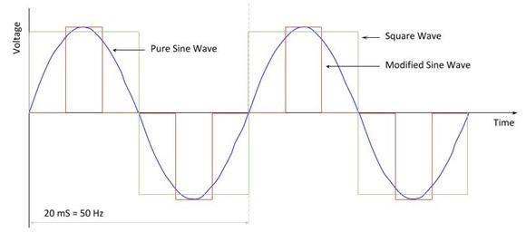

A square wave is very simple, with the d.c. supply switched between positive and negative. Depending on the circuitry, the simple square wave can be adapted to give a modified sine wave as shown. By utilising Pulse Width Modulation (see below) and filtering techniques, the waveform can be refined until it closely resemble that of a pure sine wave.

There is no exact cut off which defines a pure sine wave and various manufacturers will have differing specifications. It is generally argued that when the total harmonic distortion of the voltage waveform is less than 3%, for all practical purposes this can be considered as a true sine wave.

A lot of equipment will work well on modified sine wave inverters, including motors, household appliances and other items. Some types of loads they can be problematic and do require a pure sine wave converter. A well know example are loads requiring a pure sine wave are devices that include crystal oscillator electronic timing circuits which rely on a zero crossover of the sine wave for the functioning.

Pure sine wave inverters are more complex and cost more. It is best to select the type of inverter to match the application for which it will be used.

# **Voltage Control in Single - Phase Inverters**

The schematic of inverter system is as shown in Figure 1, in which the battery or rectifier provides the dc supply to the inverter. The inverter is used to control the fundamental voltage magnitude and the frequency of the ac output voltage. AC loads may require constant or adjustable voltage at their input terminals, when such loads are fed by inverters, it is essential that the output voltage of the inverters is so controlled as to fullfill the requirement of the loads. For example, if the inverter supplies power to a magnetic circuit, such as a induction motor, the voltage to frequency ratio at the inverter output terminals must be kept constant. This avoids saturation in the magnetic circuit of the device fed by the inverter.



**Battery**



**or**



**Rectifier**



**Inverter**



***d***



***V***



***d***



***C***



**AC**



**Voltage**

Figure 1: Schematic for Inverter System

The various methods for the control of output voltage of inverters can be classified as:

1. External control of ac output voltage
2. External control of dc input voltage

(c ) Internal control of the inverter.

The first two methods require the use of peripheral components whereas the third method requires no external components. Mostly the internal control of the inverters is dealt, and so the third method of control is discussed in great detail in the following section.

 Pulse Width Modulation Control

The fundamental magnitude of the output voltage from an inverter can be controlled to be constant by exercising control within the inverter itself that is no external control circuitry is required. The most efficient method of doing this is by Pulse Width Modulation (PWM) control used within the inverter. In this scheme the inverter is fed by a fixed input voltage and a controlled ac voltage is obtained by

adjusting the on and the off periods of the inverter components. The advantages of the PWM control scheme are [10]:

1. The output voltage control can be obtained without addition of any external components.
2. PWM minimizes the lower order harmonics, while the higher order harmonics can be eliminated using a filter.

The disadvantage possessed by this scheme is that the switching devices used in the inverter are expensive as they must possess low turn on and turn off times, nevertheless PWM operated are very popular in all industrial equipments. PWM techniques are characterized by constant amplitude pulses with different duty cycles for each period. The width of these pulses are modulated to obtain inverter output voltage control and to reduce its harmonic content. There are different PWM techniques which essentially differ in the harmonic content of their respective output voltages, thus the choice of a particular PWM technique depends on the permissible harmonic content in the inverter output voltage.

# Sinusoidal-Pulse Width Modulation (SPWM)

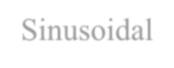

The sinusoidal PWM (SPWM) method also known as the triangulation, sub harmonic, or sub oscillation method, is very popular in industrial applications and is extensively reviewed in the literature [1-2]. The SPWM is explained with reference to Figure 2, which is the half-bridge circuit topology for a single-phase inverter



S



11



S



12



***d***



***V***



2



***d***



***V***



2



***d***



***V***



+



+



***C***



***C***



***o***



***V***

Figure 2: Schematic diagram for Half-Bridge PWM inverter.

For realizing SPWM, a high-frequency triangular carrier wave *vc* is compared with a sinusoidal reference *vr* of the desired frequency. The intersection of *vc* and *vr* waves determines the switching instants and commutation of the modulated pulse. The PWM scheme is illustrated in Figure 2.3 a, in which *vc* is the peak value of triangular carrier wave and *vr* that of the reference, or modulating signal. The figure shows the triangle and modulation signal with some arbitrary frequency and magnitude. In the inverter of Figure 2.2 the switches *S*11 and *S*12 are controlled based on the comparison of control signal and the triangular wave which are mixed in a comparator. When sinusoidal wave has magnitude higher than the triangular wave the comparator output is high, otherwise it is low.

*vr* > *vc* *S*11 is on , *Vout* =*V*2*d* (2.1)

and *vr* < *vc* *S*12 is on , *Vout* =−*V*2*d* (2.2)

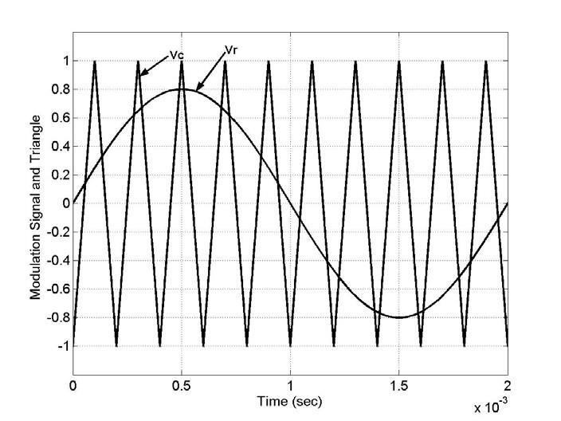

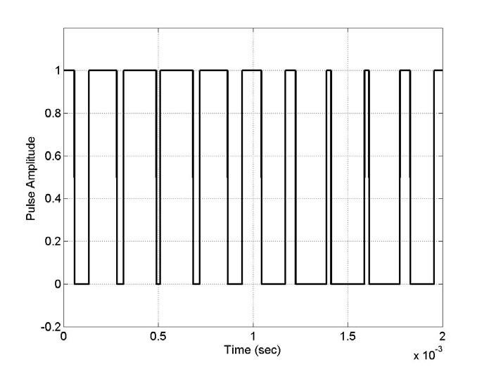

Figure 2.3: SPWM illustration (a) Sine-Triangle Comparison (b) Switching Pulses after comparison.

The comparator output is processesed in a trigger pulse generator in such a manner that the output voltage wave of the inverter has a pulse width in agreement

with the comparator output pulse width. The magnitude ratio of *vr* is called the *vc*

modulation index (*mi* ) and it controls the harmonic content of the output voltage waveform. The magnitude of fundamental component of output voltage is proportional

to *mi* . The amplitude *vc* of the triangular wave is generally kept constant. The frequency– modulation ratio *mf* is defined as

*m f* = *ffmt* (2.3)

To satisfy the Kirchoff’s Voltage law (KVL) constraint, the switches on the same leg are not turned on at the same time, which gives the condition

*S*11+*S*12 = 1 (2.4)

for each leg of the inverter. This enables the output voltage to fluctuate between

*Vd*and −*Vd* as shown in Figure 2.4 for a dc voltage of 200 V.

2 2

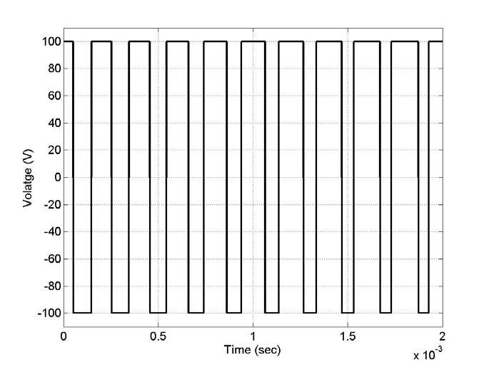

Figure 2.4: Output voltage of the Half-Bridge inverter.

## Single-Phase Inverters

A single-phase inverter in the full bridge topology is as shown in Figure 2.5, which consists of four switching devices, two of them on each leg. The full bridge inverter can produce an output power twice that of the half-bridge inverter with the same input voltage. Three different PWM switching schemes are discussed in this section, which improve the characteristics of the inverter. The objective is to add a zero sequence voltage to the modulation signals in such a way to ensure the clamping of the devices to either the positive or negative dc rail; in the process of which the voltage gain is improved, leading to an increased load fundamental voltage, reduction in total current distortion and increased load power factor. In Figure 2.5, the top devices are assigned to be S11 and S21 while the bottom devices as S12 and S22, the voltage equations for this converter are as given in the following equations.

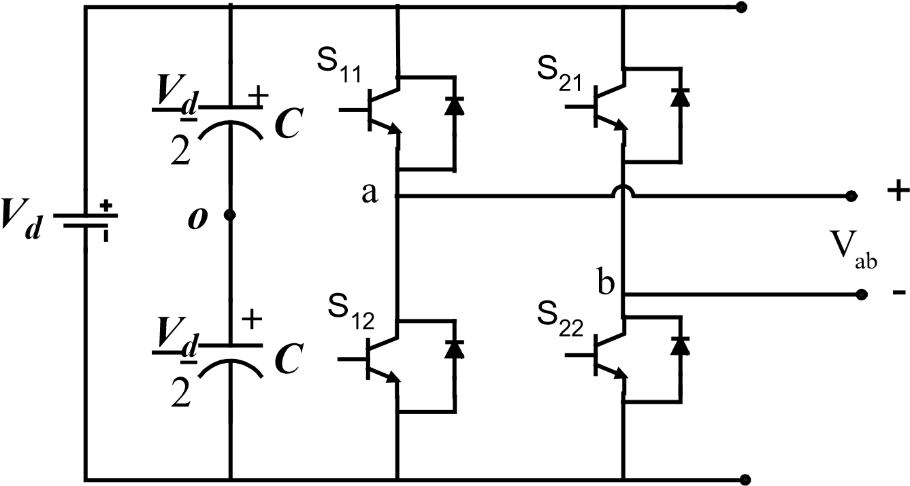

Figure 2.5: Schematic of a Single Phase Full-Bridge Inverter.

*V*2*d* (*S*11 − *S*12) =*Van* +*Vno* =*Vao* (2.5)

*V*2*d* (*S*21 − *S*22) =*Vbn* +*Vno* =*Vbo* (2.6)

*Vab* =*Van* −*Vbn* (2.7)

The voltages *Van* and *Vbn* are the output voltages from phases A and B to an arbitrary point n, *Vno* is the neutral voltage between point n and the mid-point of the DC source. The switching function of the devices can be approximated by the Fourier series to be equal to

(1+ *M*) where M is the modulation signal which when compared with the triangular waveform yields the switching pulses [19]. Thus from Equations 2.4, 2.5, and 2.6, the expressions for the modulation signals are obtained as

*M*11 = 2~~(~~*~~V~~anV*~~+~~*d ~~V~~no* ) (2.8)

*M* 21 = ~~2(~~*~~V~~bnV*~~+~~*d ~~V~~no* ). (2.9) Equations 2.8 and 2.9 give the general expression for the modulation signals for singlephase dc-ac converters. The various types of modulation schemes presented in the literature can be obtained from these equations using appropriate definition for *Van* , *Vbn* and *Vno* . Making use of this concept different modulation schemes have been proposed some of which are explained in detail in the following sections.

# SPWM with Bipolar Switching



In this scheme the diagonally opposite transistors S11, S22 and S21 and S12 are turned on or turned off at the same time. The output of leg A is equal and opposite to the output of leg B. The output voltage is determined by comparing the control signal, *Vr* and the triangular signal, *Vc* as shown in Figure 2.6(a) to get the switching pulses for the devices, and the switching pattern is as follows.

*Vr* >*Vc* , S11 is on => *Vao* = *Vd*2 and S22 is on => *Vbo* =−*Vd*2 ; (2.10) *Vr* <*Vc* , S12 is on => *Vao* =−*Vd*2 and S21 is on => *Vbo* = *Vd*2 ; (2.11)

hence

*Vbo*(*t*)=−*Vao*(*t*) (2.12)

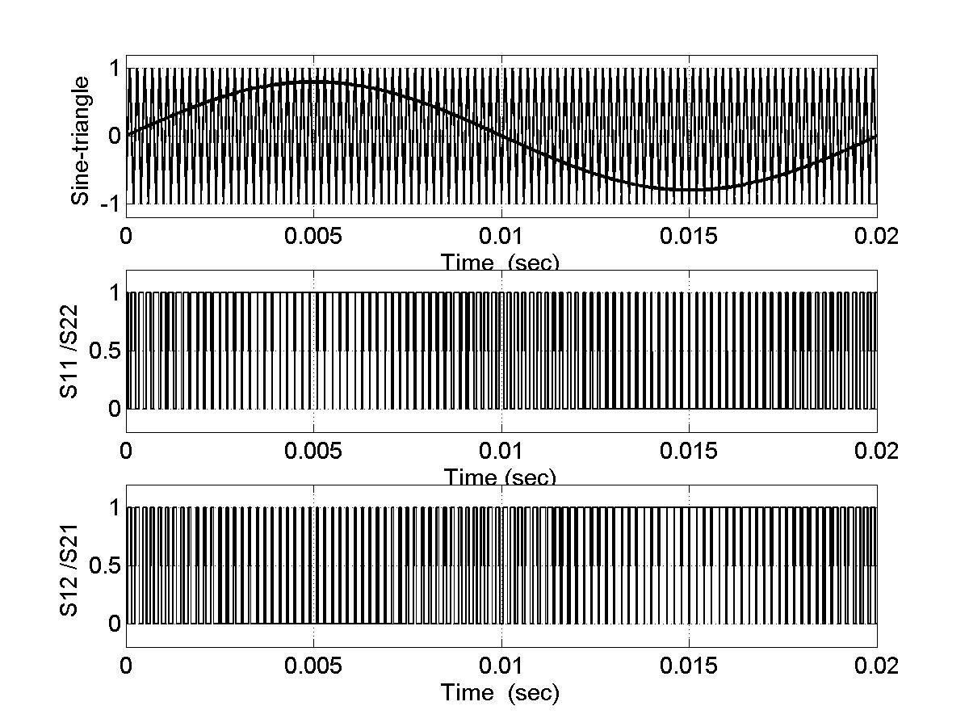

(



a)



(



b)



(



c)

Figure 2.6:Bipolar PWM (a) Sine-triangle comparison (b) Switching pulses for S11/S22 (c) Switching pulses for S12/S21

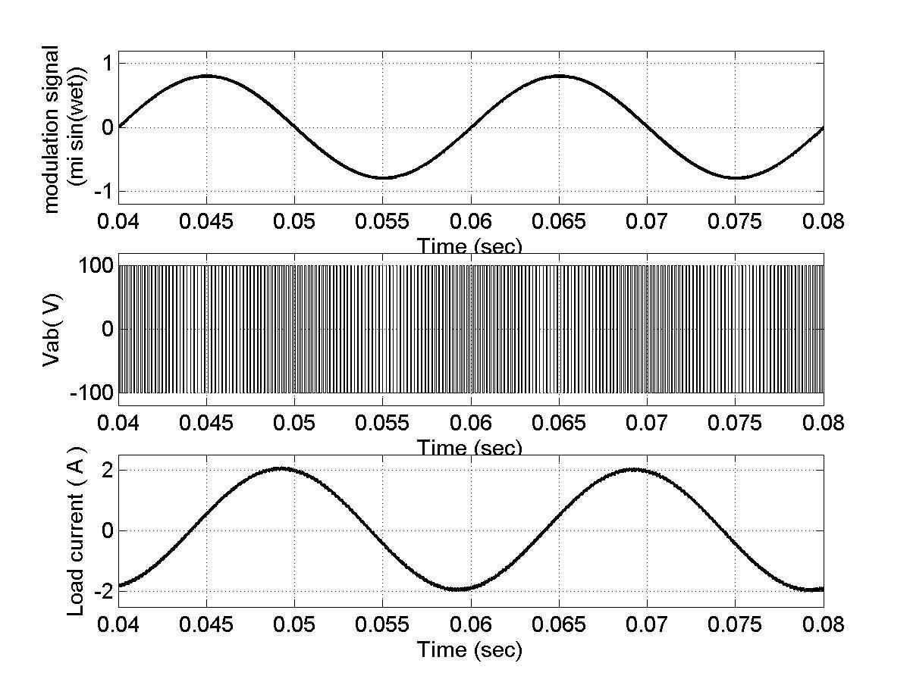

(



a)



(



b)



(



c)

Figure 2.7: Bipolar PWM scheme (a) Modulation signal for leg ‘a’ (b) output line-line voltage (c) load current

The line-to-line voltage is given as in Equation 2.13.

*Vab*(*t*)=*Vao*(*t*)−*Vbo*(*t*)=2*Vao*(*t*) (2.13)

The peak of the fundamental-frequency component in the output voltage is given as [10]

*Vab* =*miVd* (*mi* ≤ 1.0) (2.14) and

*Vd* <*Vab* <π4*Vd* (*mi* ≥1.0 ). (2.15)

Since the voltage switches between two levels −*Vd* and *Vd* , the scheme is called the Bipolar PWM. The relationship between fundamental input and output voltage in the overmodulating region is given as [10].

*Vo* =*MVd* (2.16)

where

*M* = 2π*mi* (sin−1α+α 1−α2 ) ,*mi* >1 α=1/ *mi* .

For a full-bridge inverter with bipolar PWM scheme the output voltage is between

−*~~V~~d* and *Vd* . Figure 2.7 shows the modulation signal, output voltage, and the load

2 2

current for bipolar modulation scheme on a single-phase inverter with an RL load of 10 Ω and 0.125H.

For the bipolar PWM switching scheme there is only one modulation signal and the switches are turned ‘on’ or turned ‘off’ according to the pattern given in Equations 2.10 and 2.11. The input dc voltage was 200 V and the modulation index (mi) was taken to be

0.8. The switching frequency for the carrier, which is the triangle, is 10 kHz.

SPWM With Unipolar Switching

In this scheme, the devices in one leg are turned on or off based on the comparison of the modulation signal *Vr* with a high frequency triangular wave. The devices in the other leg are turned on or off by the comparison of the modulation signal −*Vr* with the same high frequency triangular wave. Figure 2.8 and 2.9 show the unipolar scheme for a single – phase full bridge inverter, with the modulation signals for both legs and the associated comparison to yield switching pulses for both the legs.

In Figure 2.8 the simulation results show the sine triangle comparison, the switching pulses for S11 and S21 are shown. The switching for the other two devices is obtained as S12 = 1 – S11 and S22 = 1- S21. Figure 2.9 shows the phase voltages , line toline voltages obtained from a unipolar PWM scheme , also shown is the load current. The simulation was carried out for an RL load of R = 10Ω and L = 0.125H. The dc voltage is

200 V and the switching frequency is 10kHz. The modulation signal

has 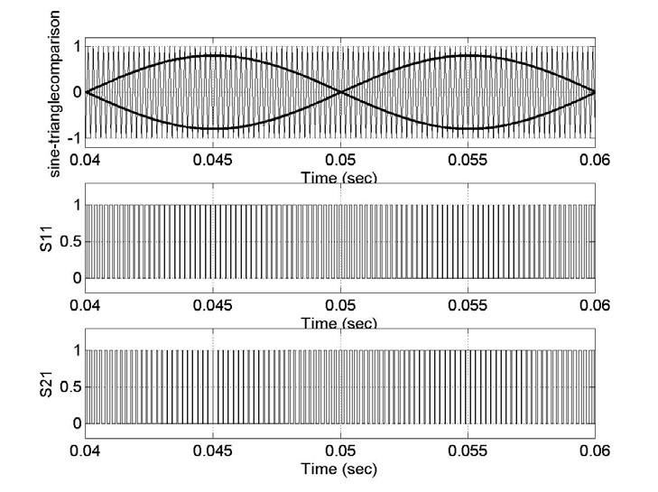 a

magnitude of 0.8, i.e mi = 0.8.

Figure 2.8: Unipolar PWM voltage switching scheme (a) Sine triangle comparison (b) switching pulses for S11 (c) switching pulses for S21.

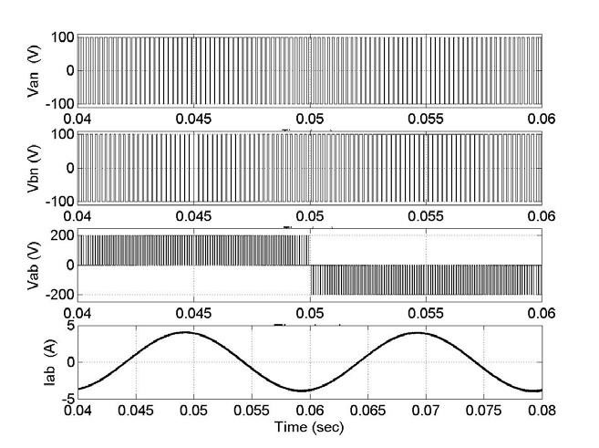(a)

(b)

(c)

(d)

Figure 2.9: Unipolar PWM voltage switching scheme (a) phase voltage ‘a’ (b) phase voltage ‘b’ (c) line to line voltage Vab (d) load current

The logic behind the switching of the devices in the leg connected to ‘a’ is given as

*Vr* > *Vc* : *S*11is on and *Van* = *V*2*d* (2.17)

*Vr* <*Vc* : *S*11is on and *Van* = −*V*2*d* (2.18) and

that in the leg connected to ‘b’ is given as

-*Vr* >*Vc* : *S*11is on and *Vbn* = *V*2*d* (2.19)

-*Vr* <*Vc* : *S*11is on and *Vbn* = −*V*2*d* (2.20)

Table 2.1 shows the switching state of the unipolar PWM and the corresponding voltage levels. It can be observed from the table that when the two top or the two bottom devices are turned on the output voltage is zero.

In Unipolar switching scheme the output voltage level changes between either 0 to -*Vd* or from 0 to +*Vd* . This scheme ‘effectively’ has the effect of doubling the switching

frequency as far as the output harmonics are concerned, compared to the bipolar- switching

□ scheme. The voltage waveforms *Van* and *Vbn* are 180 out of phase from each other as seen in Figure 2.10. The output voltage *Vab* is as shown in

Figure 2.11 along with the load current.

Since the harmonic components at the switching frequency in *Van* and

*Vbn* have the same frequency, this results in the cancellation of the harmonic component at the switching frequency in the output voltage.

Table 2.1. Switching state of the unipolar PWM and the corresponding voltage levels.

|  |  |  |  |  |  |  |
| --- | --- | --- | --- | --- | --- | --- |
| *S*11 | *S*12 | *S*21 | *S*22 | *VAn* | *VBn* | *Vo* =*VAn* −*VBn* |
| ON | - | - | ON | *Vd* | 0 | *Vd* |
| - | ON | ON | - | 0 | *Vd* | -*Vd* |
| ON | - | ON | - | *Vd* | *Vd* | 0 |
| - | ON | - | ON | 0 | 0 | 0 |

The fundamental component of the output voltage is given as

*Vo* =*miVd* (*mi* ≤1.0) (2.21)

*Vd* < *Vo* <π4 *Vd* (*mi* >1.0 ). (2.22)

# SPWM With Modified Bipolar Switching Scheme (MBPWM)

In the inverter employing the bipolar switching scheme, switches are operated in such a way that during the positive half of the modulation signal one of the top devices in one of the switching leg is kept on and the two other switching devices in the other leg are PWM operated, and during the negative half of the modulation signal one of the bottom switching device is kept on continuously while the other two switching devices in the other leg are PWM operated. The output voltage is determined by comparing the control signal

Vr and the triangular wave.

The switching pattern along with the sine-triangle comparison is as shown in Figure

2.10. The switching pattern for positive values of modulating signal *Vm* is as given

*Vr* > *Vc* , *S*21 is on (2.23) and *Vr* <*Vc* , *S*22 is on .

(a)

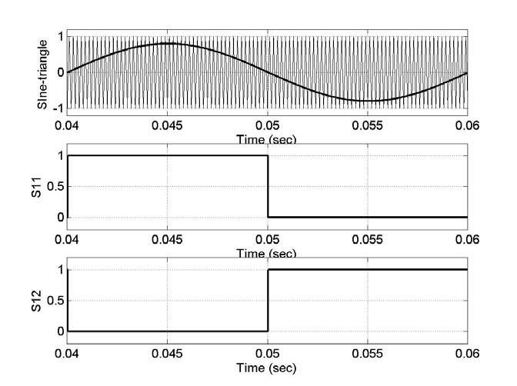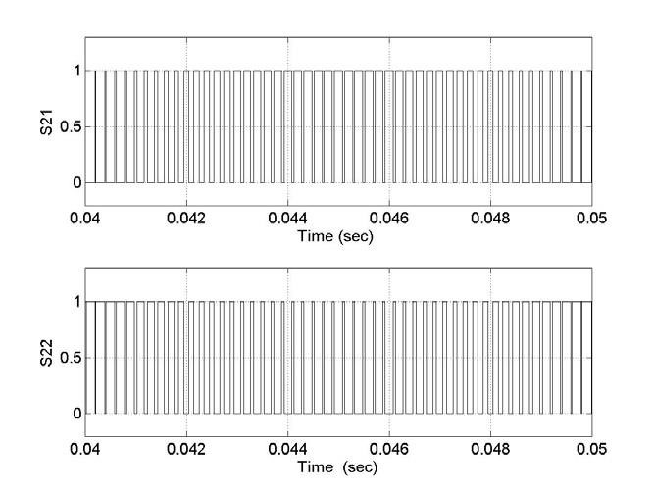

(b)

(c)

(d)

(e)

Figure:Modified bipolar PWM (a) Sine-triangle comparison (b), (c), (d), and (e) switching pulses for devices S11, S12, S21 and S22.

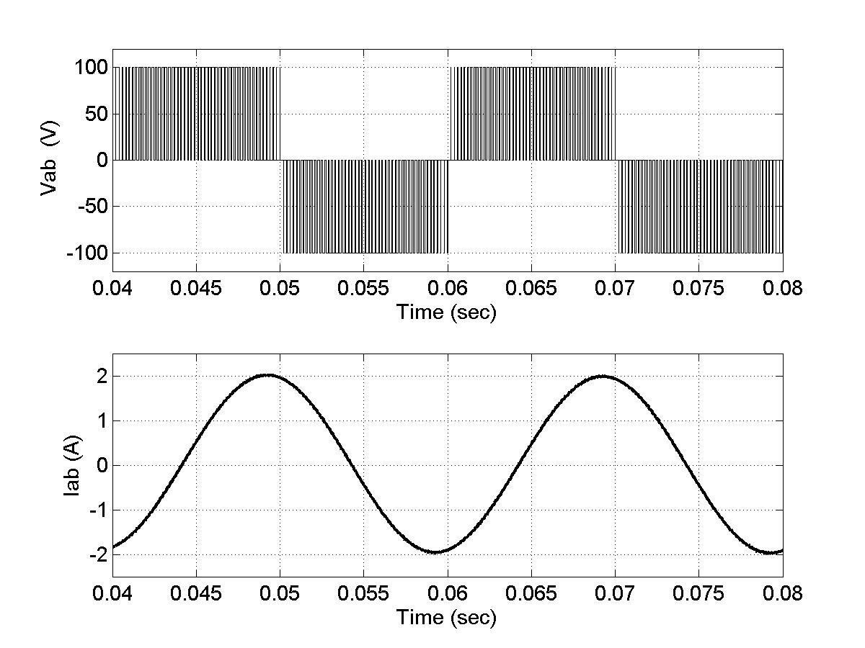

(



a)



(



b)

Figure 2.11: Modified bipolar PWM scheme (a) line-to-line voltage (b) load current

The switching pattern for negative values of the modulating signal *Vm* is given as

*Vr* < *Vc* , *S*21 is on (2.24) and *Vr* > *Vc* , *S*22 is on .

The output voltage is given as *Vo*(*t*)=*VAn*(*t*)−*VBn*(*t*), as shown in Figure 2.11. The load current is also shown in the same plot. The RL load has an R = 10 Ω and L = 0.125H. The modulation signal for the sine-triangle comparison is 0.8. The switching pattern for the Modified Bipolar Switching Scheme is as given in Table 2.2.

Table 2.2. Switching state of the modified bipolar PWM and the corresponding voltage.

|  |  |  |  |  |  |  |
| --- | --- | --- | --- | --- | --- | --- |
| *S*11 | *S*12 | *S*21 | *S*22 | *VAn* | *VBn* | *Vo* =*VAn* −*VBn* |
| ON | - | - | ON | *Vd* | 0 | *Vd* |
| - | ON | ON | - | 0 | *Vd* | -*Vd* |
| ON | - | ON | - | *Vd* | *Vd* | 0 |
| - | ON | - | ON | 0 | 0 | 0 |

From Table 2.2 it can be observed that when the two top or the two bottom devices are turned on the output voltage is zero.

In the modified bipolar switching scheme the output voltage level changes between either 0 to -*Vd* or from 0 to +*Vd* . Since the sign of the modulation signal decides the switching pattern the analysis of this switching scheme is complex. The relationship between input and output voltage is given as [14],

*Vo* =*mVd*

(2.25) where *m*=0.5(*mi* +π4) ( *mi* <1.0 ) . (2.26)

Thus from the above equation it can be observed that the fundamental component of the voltage as obtained from the MBPWM is the maximum when compared to the other switching schemes even in the linear modulation region; that is when the modulation index is less than unity.

**Sinusoidal PWM Technique**

Sinusoidal [PWM](https://www.sciencedirect.com/topics/engineering/pulse-width-modulation) is a typical [PWM technique.](https://www.sciencedirect.com/topics/engineering/pulse-width-modulation-technique) In this PWM technique, the sinusoidal AC voltage reference vref is compared with the high-frequency triangular carrier wave vc in real time to determine switching states for each pole in the [inverter.](https://www.sciencedirect.com/topics/engineering/inverter) After comparing, the switching states for each pole can be determined based on the following rule:

•

Voltage reference vref>Triangular carrier vc: upper switch is turned on (pole voltage=Vdc/2)

•

Voltage reference vref<Triangular carrier vc: lower switch is turned on (pole voltage=−Vdc/2)

Here, the peak-to-peak value of the triangular carrier wave is given as the DC-link voltage Vdc. In this PWM technique, the necessary condition for linear modulation is that the amplitude of the voltage reference vref must remain below the peak of the triangular carrier vc, i.e., vref≤Vdc/2. Since this PWM technique utilizes a highfrequency carrier wave for voltage modulation, this kind of PWM technique is called a carrier-based PWM technique. Especially, this carrier-based technique is called SPWM since the reference is given as the shape of a sine wave. This is also called the triangle-comparison PWM technique since this uses the carrier of a triangular wave. Fig. 7.29 depicts the sinusoidal PWM technique for one phase.

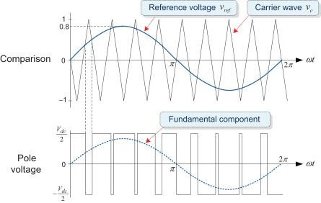

Modulating Wave and Carrier Wave

In the carrier-based [PWM techniques,](https://www.sciencedirect.com/topics/engineering/pulse-width-modulation-technique) the desired voltage reference waveform is referred to as *modulating wave*. In addition, a wave which is modulated with the modulating wave is referred to as *carrier wave* or *carrier*. The carrier wave usually has a much higher frequency than the modulating wave. The triangular waveform is the most commonly used carrier in the PWM technique for modulating AC voltage. On the other hand, different forms of modulating wave can be used according to the PWM technique. Typical [SPWM technique](https://www.sciencedirect.com/topics/engineering/pulse-width-modulation-technique) uses the sinusoidal modulating waveform.

***Difference Between Pole Voltage and Phase Voltage References***

An inverter output determined by comparing a voltage reference with the triangular carrier wave is the pole voltage. Thus the voltage reference that is compared with the triangular carrier wave is considered as the pole voltage reference. Typical SPWM technique uses a [phase voltage](https://www.sciencedirect.com/topics/engineering/phase-voltage) reference as the pole voltage reference. On the other hand, different pole voltage reference can be used according to the PWM techniques.

In this PWM based on comparison with the triangular wave, if the ratio of carrier frequency to fundamental frequency is large enough (greater than 21), then the fundamental component of the output voltage varies linearly with the [reference voltage](https://www.sciencedirect.com/topics/engineering/reference-voltage) vref for a constant DC-link voltage as vo1=vrefsinωt

In addition, the fundamental frequency of the output voltage is identical to that of the reference voltage.

The output voltage can be rewritten in terms of the [modulation index](https://www.sciencedirect.com/topics/engineering/modulation-index) *MI* as v01=Vdc2MIsinωt

Here, since vref≤Vdc/2, so 0≤MI≤1.

The range of 0≤MI≤1 is called the *linear modulation range* because, in this range, the inverter can generate an output voltage linearly proportional to the reference voltage as shown in Fig. 7.30. In this case, the PWM inverter is considered to be simply a voltage amplifier with a unit gain.

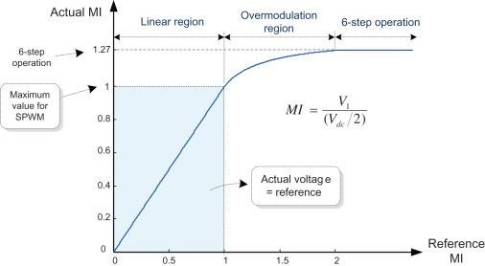

Figure : Voltage Modulation range for SPWM

However, when the reference exceeds the peak of the triangular carrier (i.e., MI>1), the inverter cannot produce an output voltage linearly proportional to the voltage reference. The range of MI>1 is called *overmodulation region*, where the linearity of the modulation is lost. We will discuss the overmodulation techniques

The maximum linear output voltage, Vdc/2, attainable by the SPWM technique corresponds to 78.5% of the maximum output voltage, 2Vdc/π, by the six-step inverter. Therefore, when using the PWM technique, the attainable maximum limit of the linear modulation range is inevitably less than the maximum output voltage of an inverter.

Fig. 7.31 shows the SPWM technique for a three-phase inverter.

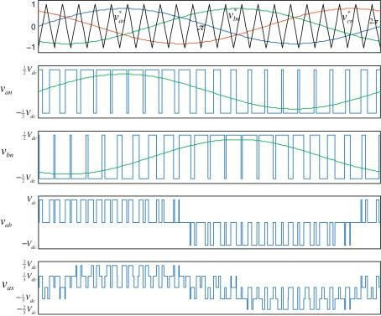

Figure : SPWM technique for a three phase inverter

In the SPWM technique, the switching frequency of an inverter is equal to that of a carrier wave. From Figs. 7.29 and 7.31, we can see that the switch is turned on/off once every period of the triangular carrier wave. Thus the SPWM technique has an advantage of having a constant switching frequency. A constant switching frequency makes it possible to calculate the losses of switching devices, so the thermal design for them becomes easier. In addition, since the harmonic characteristics will be well-defined, the design of a low-pass filter to eliminate the harmonics will become easier.

Now we will evaluate which harmonics are contained in the output voltage generated by the

SPWM technique. First, we will investigate the [harmonic components](https://www.sciencedirect.com/topics/engineering/harmonic-component) of the pole voltage vP as shown in Fig. 7.29. It is widely known that the pole voltage contains harmonics at the carrier frequency fc and frequencies of its integer multiples (*M*), and the [sidebands](https://www.sciencedirect.com/topics/engineering/sidebands) (*N*) of all these frequencies [4]. Thus these harmonics, which are known as switching frequency harmonics, can be expressed as

vo−h=Vhsin[2π(Mfc±Nfo)t+ϕh]=Vhsin[2πfo(Mmf±N)t+ϕh]

Here, fo is the fundamental frequency of the output voltage and mf is the *frequency modulation index*, which denotes the ratio of the carrier frequency to the fundamental frequency, i.e., mf=fc/fo. *M* and *N* are integers, and *M*+*N* is odd. *ϕh* denotes the phase of harmonic component. From Eq. (7.42), the orders of harmonics are given as mf,mf±2,mf±4,mf±6,…2mf±1,2mf±3,2mf±5,2mf±7,…3mf,3mf±2,3mf±4,3mf±6,…4mf±1,4 mf±3,4mf±5,4mf±7,…

Among the harmonics, the component of order mf has the largest magnitude. This means that the harmonic with the frequency equal to the switching frequency fc is the largest one.

As an example, Fig. 7.32 shows the frequency spectrum for the pole voltage of fo=50Hz and mf=21. In this case, the harmonic of 1050 Hz(=21×50 Hz), i.e., the switching frequency is the largest component.

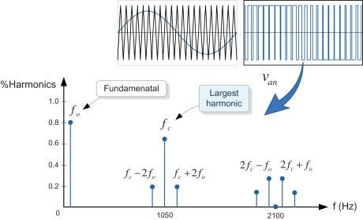

Figure : Frequency spectrum of the pole voltage for the SPWM

The higher the switching frequency is, the higher the order of the major harmonic is. Thus, when a higher switching frequency is used, the quality of the [voltage waveform](https://www.sciencedirect.com/topics/engineering/voltage-waveform) can be improved and filtering can be made easier. However, this leads to greater switching losses. Therefore it is important to consider the overall performance of the system when selecting the switching frequency.

Next we will examine the harmonic components for the line-to-line and [phase voltages.](https://www.sciencedirect.com/topics/engineering/phase-voltage) Since the line-to-line voltage is the difference between the two pole voltages, they do not have any harmonic at multiples of three, which exist in the pole voltages. As mentioned earlier, this is because the harmonics at multiples of three included in the pole voltages will have no phase difference with each other. Hence, if we select the value of mf as multiples of three, then the total harmonics will be reduced in the line-to-line voltage due to the elimination of the harmonics at multiples of three. For this reason, the value of mf is usually selected as multiples of three. Furthermore, among these values, only the odd values can eliminate the even harmonics for the symmetry of three-phase PWM patterns. In that case, the harmonic of order 2mf±1 becomes the largest component for the range of *MI*<0.9, while mf±2 around *MI*=1. For example, Fig. 7.33 depicts the [harmonic spectrum](https://www.sciencedirect.com/topics/engineering/harmonic-spectrum) for the lineto-line voltage in the case of mf=21 and *MI*=0.8. In this case, unlike that of the pole voltage, the largest harmonic component becomes the order of 2mf±1. The phase voltages have harmonic components identical to those of the line-to-line voltages, but their magnitudes are different.

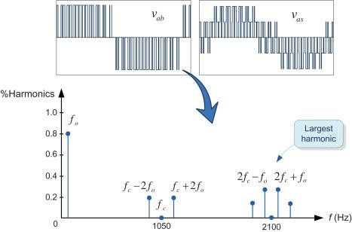

Figure : Frequency spectrum of the line to line voltage for the SPWM(MI=0.8, mf=21)

The SPWM technique has been widely popular due to the simplicity of its principle and analog implementation. In the analogue implementation of the SPWM (referred to as *naturally sampled PWM*), an analog [integrator](https://www.sciencedirect.com/topics/engineering/integrator) is used to generate a triangular carrier wave, and an [analog comparator](https://www.sciencedirect.com/topics/engineering/analog-comparator) is used to determine the intersection instants of the triangular carrier wave and modulating signal.

In contrast, its software-based implementation using a digital technique or microprocessor is not easy because this requires solving the transcendental equation, which defines points of intersection used to determine the switching instants. Instead, as shown in Fig. 7.34, the socalled *regular-sampled PWM* is used in which the sinusoidal reference is held at a constant sampled value for the carrier interval, and the sampled value is compared with the carrier wave to determine the switching instants [5]. In the regular-sampled PWM, there are two types of sampling, *symmetric* and *asymmetric*. In the symmetrical sampling of Fig. 7.34A, the sinusoidal reference is sampled once at the peak of the triangular carrier wave, whereas in the asymmetrical sampling of Fig. 7.34B, it is sampled twice at both the positive and negative peaks of the triangular carrier wave. Nowadays, its digital implementation can be easily done by using microcontrollers supporting the dedicated module for the PWM signal generation.

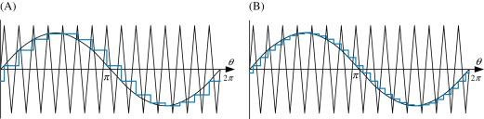

Figure : Regular –sampled PWM technique (A) Symmetrically sampling and (B) asymmetrically sampling

Since the SPWM technique can perform voltage modulation every sampling interval with a fixed switching frequency, it exhibits a better dynamic performance than the programmed PWM. However, this technique has a limited voltage linearity range (only 78.5% of six-step operation) and a poor waveform quality in the high modulation range. To overcome these problems, many improved PWM techniques have been developed. Improvements to extend the voltage linearity range have been mainly done through the modification of the modulating signal, resulting in nonsinusoidal modulating signals. As a typical example of the improvement, the *third harmonic injection PWM* makes it possible to increase the fundamental component of the output voltages by 15.5% more than the conventional SPWM technique.

**MATLAB Simulations Sinusoidal PWM :**

Bipolar Sinusoidal PWM –

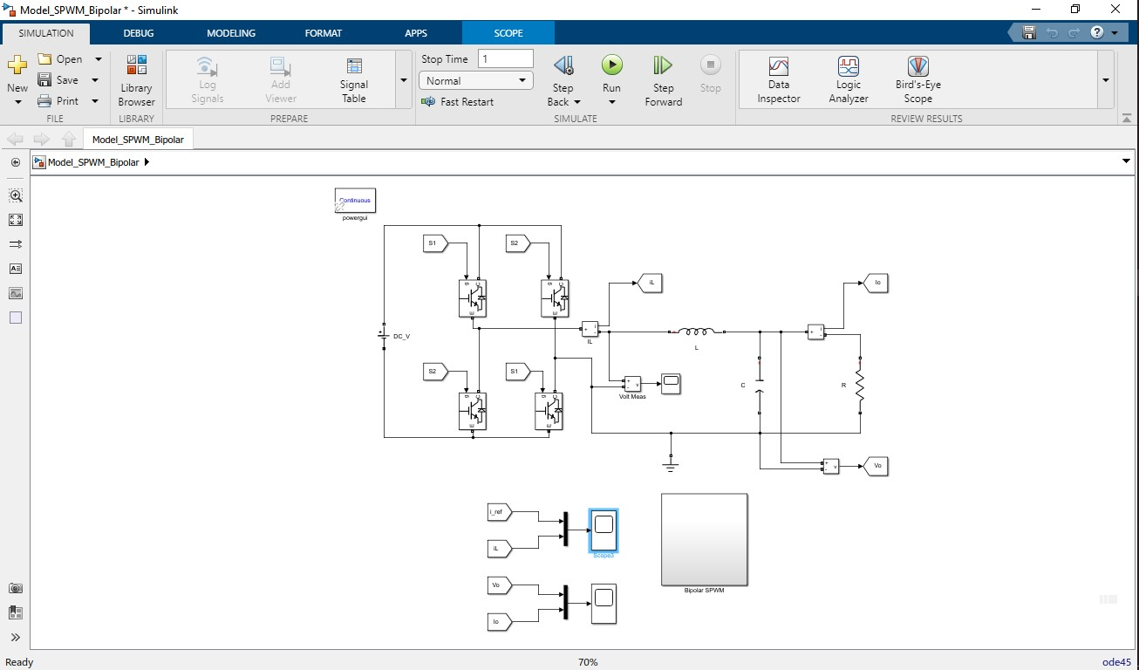

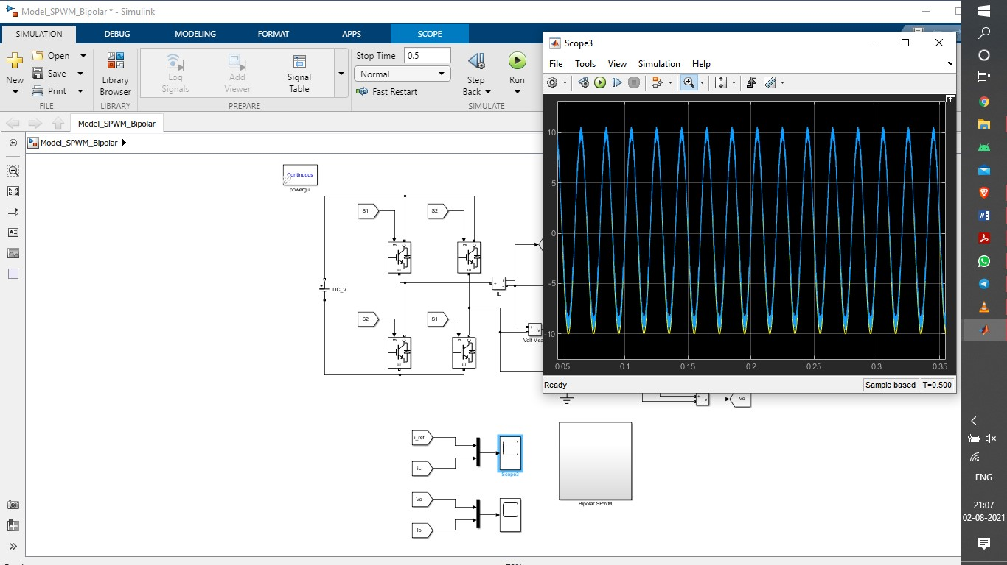

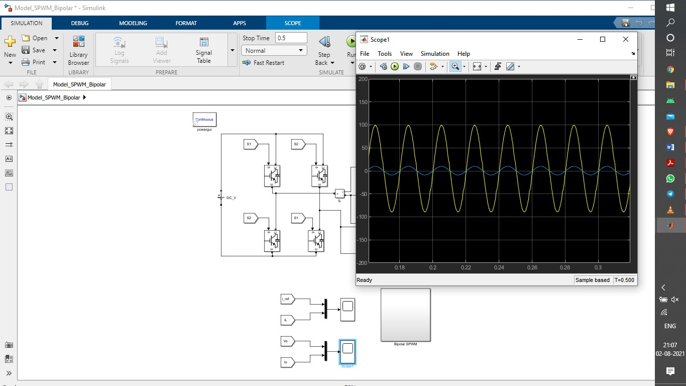

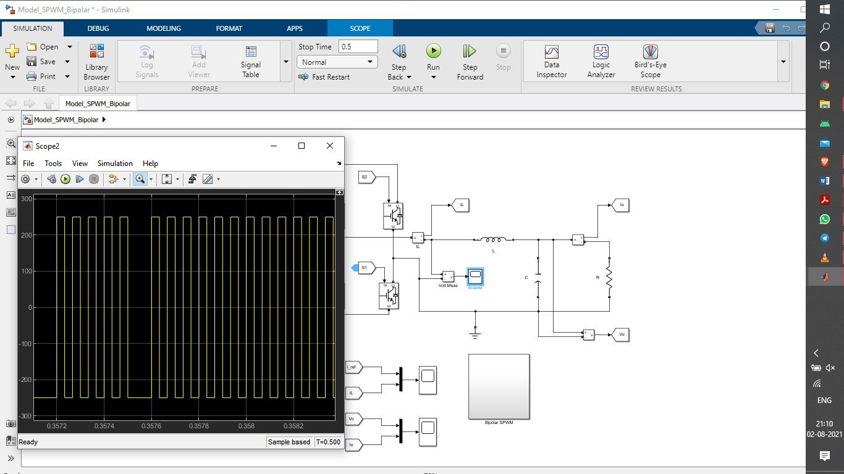

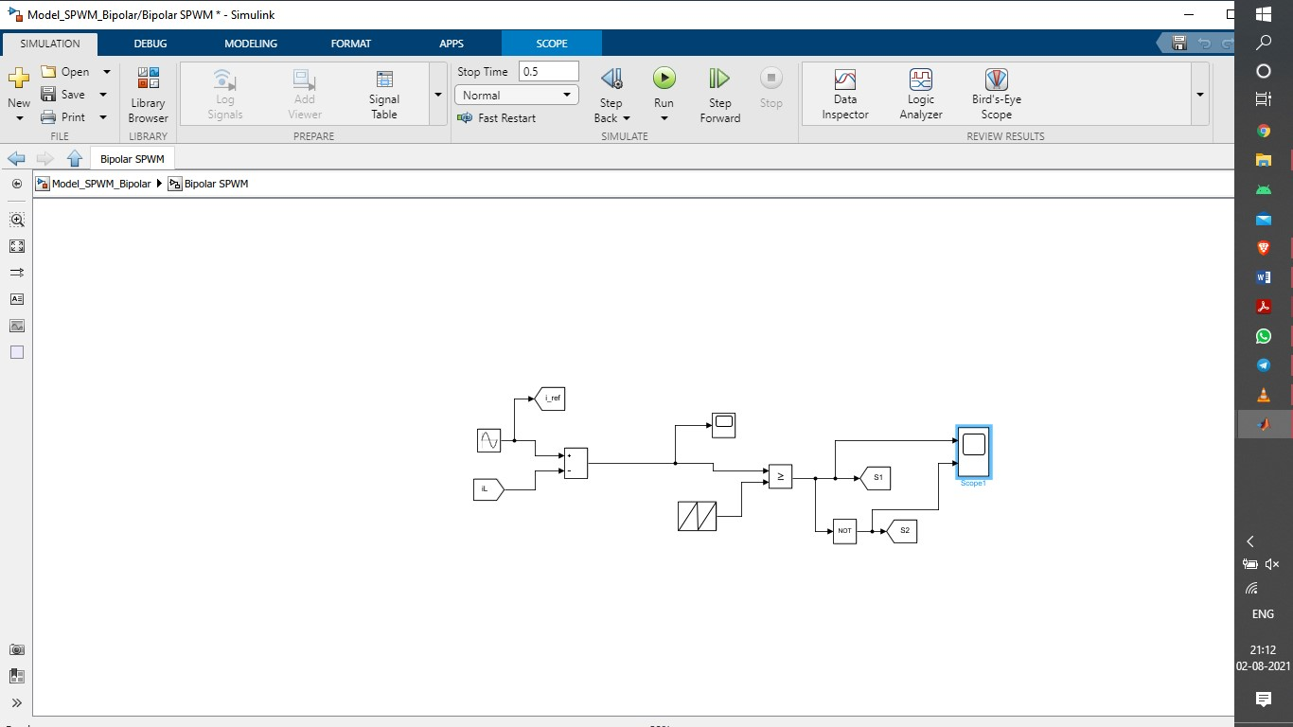

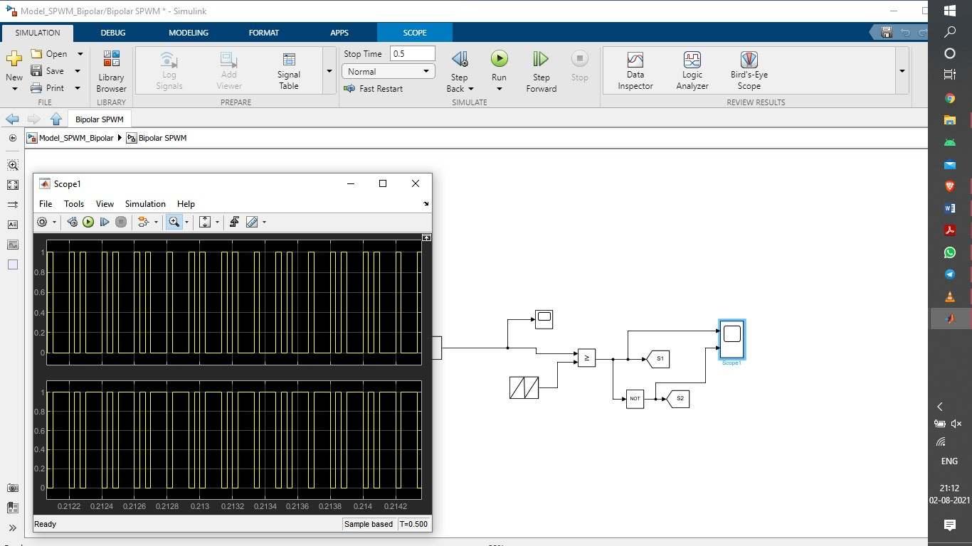

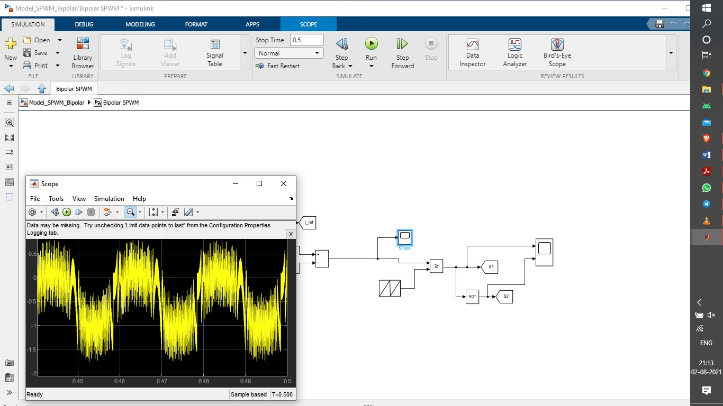

Unipolar Sinusoidal PWM –

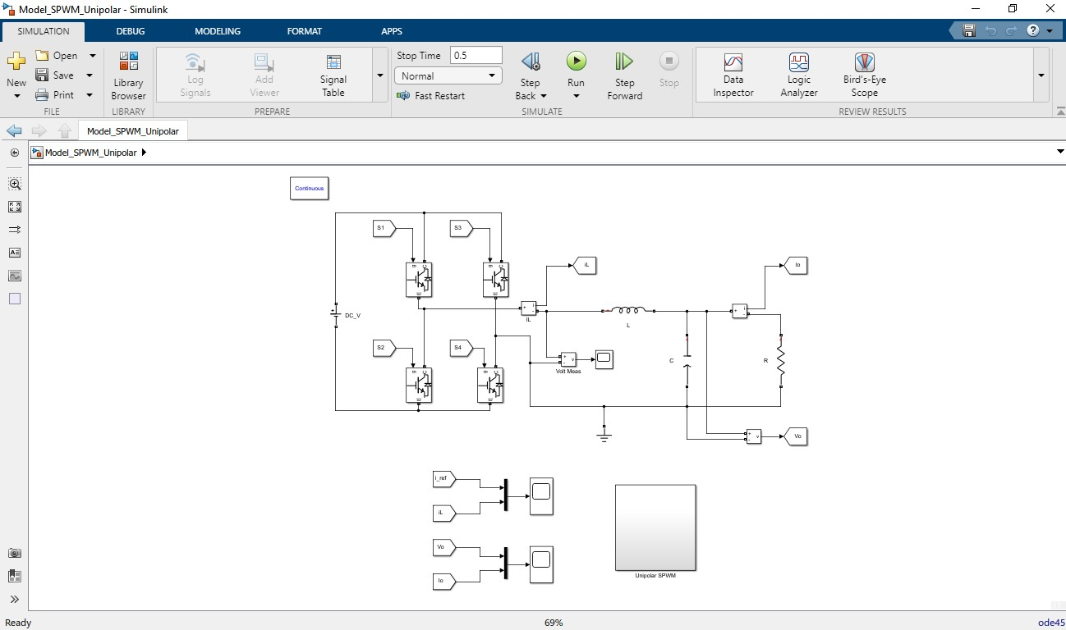

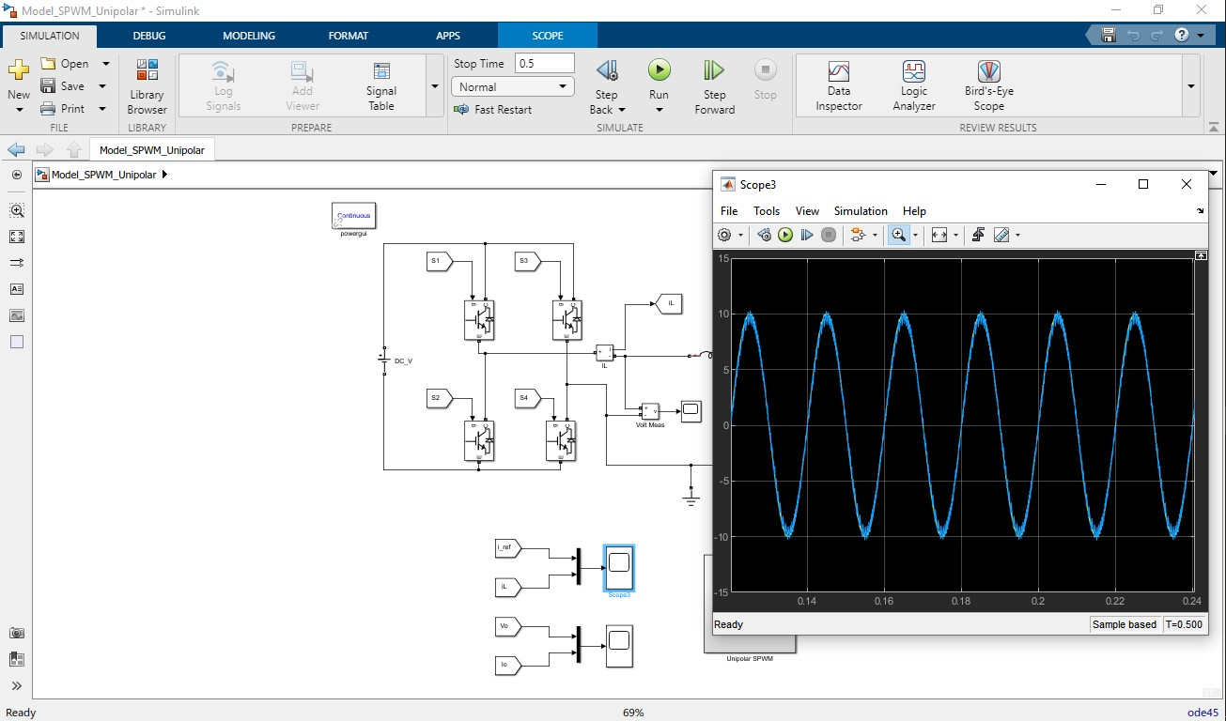

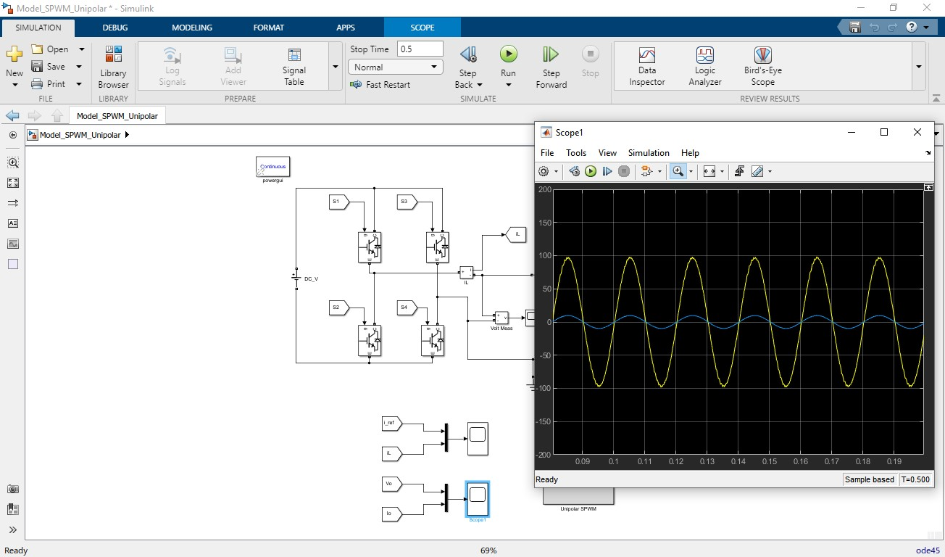

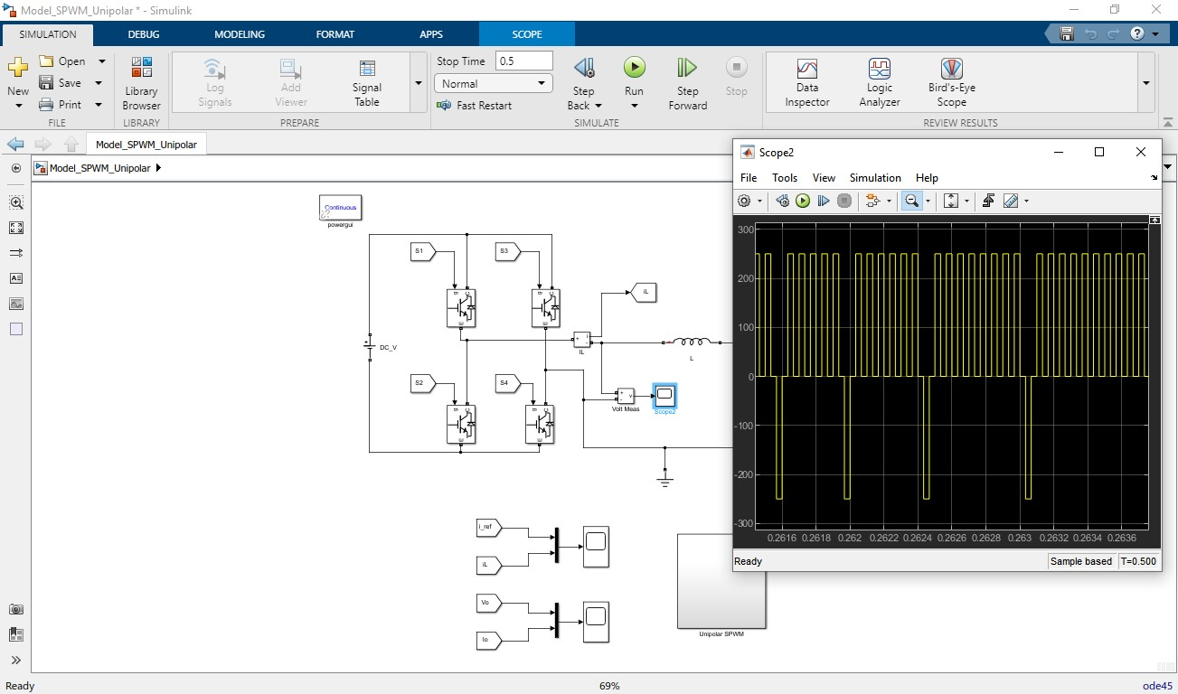

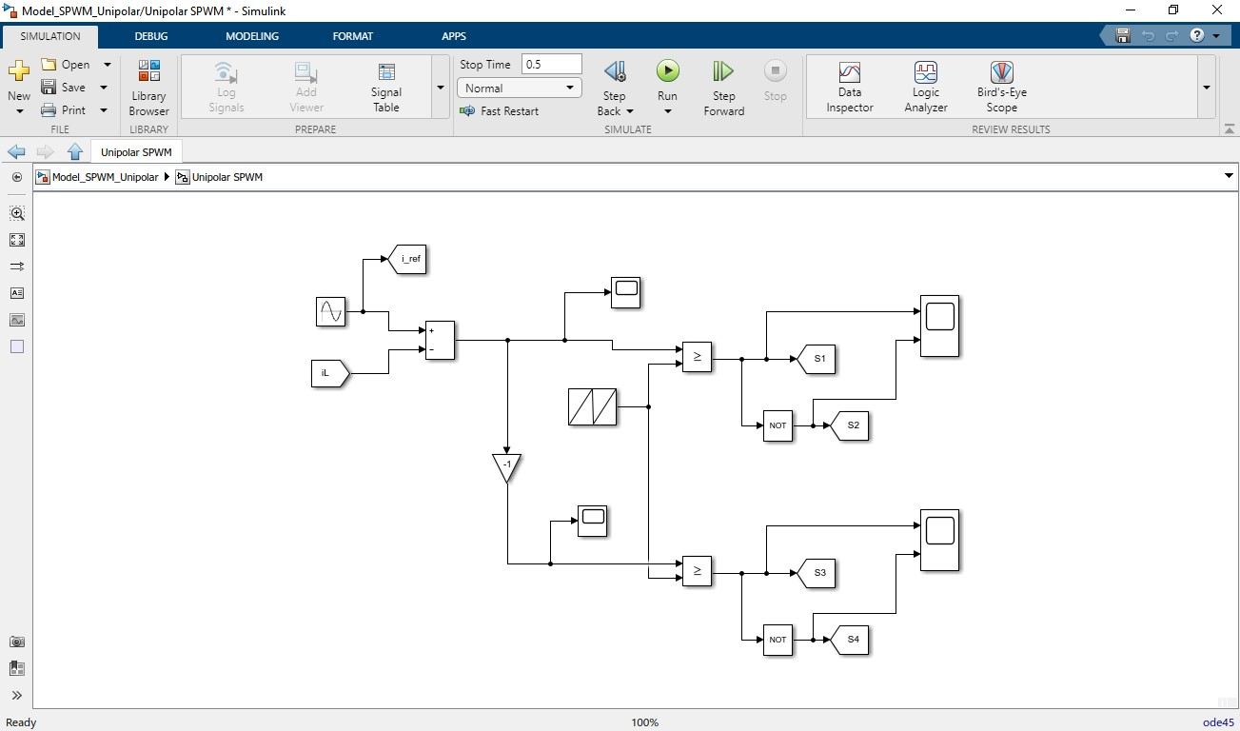

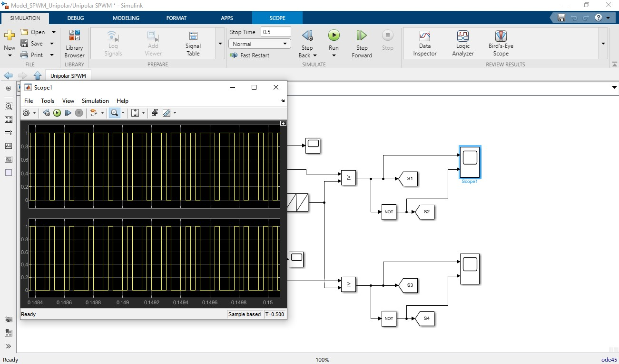

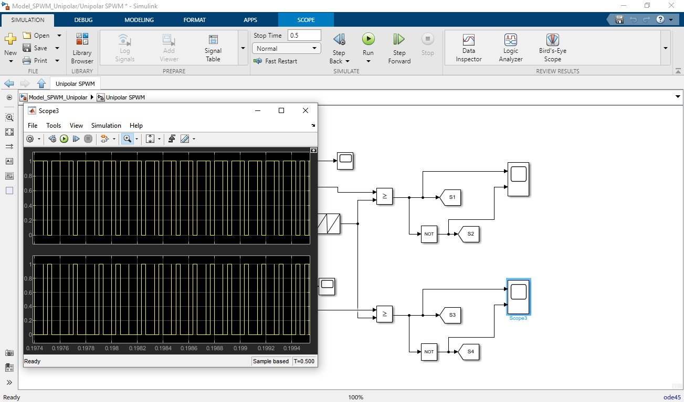

**References**

* **Renewable Energy Systems F L luise**
* **Power Electronics** devicesl**,** circuits and applications

**Mohammed H. Rashid**

* **Simulations of power Electronics**

**Hadeed Ahmed**

* **Wikipedia’s articles**
* **MATLAB libraries**